The All-In Cost of an Ounce of Gold
Production economics, the global cost map, 56 years of price vs. cost, and who holds the gold
Research briefing · Data as of 21 July 2026 · Companion to the interactive dashboard
Illustrative research — not investment advice, and not a recommendation to buy, sell or hold gold or any other asset. The three investor “reads” in section 6 are AI simulations of documented public positions, not statements by, or endorsed by, the named individuals.
The one-line answer. The latest reliable global-average all-in sustaining cost (AISC) to produce gold is about $1,700 per ounce. The World Gold Council pegs Q4 2025 AISC at $1,706/oz (up 20% year-on-year, a record); Metals Focus’ Q4 2025 cost curve sits near a $1,709 median. Adding growth capital and exploration lifts the all-in cost (AIC) to ≈$1,946/oz; a further 15% for tax & finance gives a fully-loaded cost of ≈$2,238/oz. With gold near $4,010, producers still earn a margin of $1,800–2,300/oz depending on the cost lens — the widest in the industry’s modern history — even though costs are simultaneously at all-time highs.

1. The headline numbers
Gold trades near $4,010 per ounce as of 20 July 2026 — up roughly 19.6% over the prior twelve months and in all-time-high territory. The annual average price was $3,432 in 2025 and $2,386 in 2024 — up ~44% year on year, and roughly double its 2023 level. Against that, the cost of pulling an ounce out of the ground has risen too, but far more slowly.
Cost measure | US$/oz | What it captures
Total cash cost | ≈ 1,235 | On-site mining, processing, site G&A, refining and royalties — the pre-2013 industry standard.
AISC (all-in sustaining) | ≈ 1,706 | Cash cost plus sustaining capital, corporate overhead and reclamation. WGC standard since 2013; Q4 2025 global average.
AIC (all-in cost) | ≈ 1,946 | AISC plus growth/expansion capital and greenfield exploration — the cost of building the next mine.
Fully-loaded cost | ≈ 2,238 | AIC plus a 15% charge for tax & finance (income tax, interest, financing) — the truest cost to the business.
Margin at spot (per lens) | 1,772–2,304 | Spot minus cost: ≈57% of price vs AISC, ≈51% vs AIC, ≈44% vs fully-loaded.

Two facts sit in tension and both are true: costs have never been higher in nominal terms, and margins have never been wider. That is the paradox the rest of this briefing unpacks.

2. Anatomy of a produced ounce
“Cost” is not a single number; it is a ladder of ever-more-complete definitions. Each rung adds a real category of spending that the one below it ignores.
- Cash cost (≈$1,235). What it takes to get metal out of rock today — mining and hauling ore, processing and refining it, running the site, and paying royalties and production taxes.
- AISC (≈$1,706). Introduced by the World Gold Council in 2013 to end the fiction that cash cost was the “real” cost. It adds sustaining capital (the money spent every year just to keep current production going — equipment, capitalised stripping, underground development), corporate overhead, and mine-site reclamation.
- AIC (≈$1,946). Adds the truly forward-looking money: growth and expansion capital, and greenfield exploration to replace the reserves being depleted. This is the number that determines whether the industry can reproduce itself.
- Fully-loaded (≈$2,238). Adds a 15% charge for tax & finance — corporate income tax plus the interest and financing cost of the capital a mining business deploys (here modelled at 15% of AIC, ≈$292/oz). It answers “what does an ounce really cost the business,” not just the mine.
In WGC’s Q3 2024 data the two largest “above-cash” components were sustaining capital at $303/oz and royalties/mining taxes at $90/oz — the latter rising fast (up 31% year-on-year) precisely because royalties are levied on a soaring gold price. The chart below builds one representative ounce from the bottom up, through all four cost definitions.
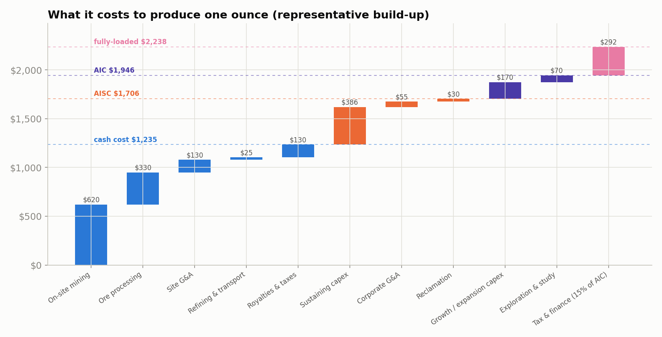
Figure 1 — Representative build-up: cash cost → AISC → AIC → fully-loaded. Blue = cash cost; orange = sustaining; violet = growth/exploration; magenta = tax & finance.

3. The global cost map: by country and region
Where an ounce comes from largely sets what it costs. The single biggest driver is geology — ore grade and depth — followed by energy, labour, currency and royalty regime. Deep, old, grade-depleted mines sit at the top of the cost curve; shallow open pits and by-product operations sit at the bottom.

Regional picture (WGC, Q3 2024)
South America was the lowest-cost region at $1,197/oz, helped by large by-product-credit operations; Oceania (mostly Australia) sat at $1,464; North America at $1,508; and Africa was the most expensive at $1,532/oz, dragged up by South Africa’s ultra-deep mines. Company results show how wide the spread runs: Endeavour Mining averaged $1,433/oz across West Africa, while Harmony Gold’s South African operations averaged $1,806/oz. Russia and Central Asia are structurally low (roughly $900–1,300/oz) though reporting there is less transparent.

Leading producers
Global mine production hit a record in 2025 — an estimated 3,672 tonnes (WGC), edging past the 2018 record — with total supply of 5,076 tonnes once 1,404 tonnes of recycling is added. The table shows the largest producers, their estimated cost position, and their in-ground reserves.
Country | Region | Prod. 2024 (t) | Est. AISC ($/oz) | Reserves (t)
China | Asia | 380 | 1,500 | 3,100
Russia | CIS | 310 | 1,150 | 12,000
Australia | Oceania | 290 | 1,700 | 12,000
Canada | North America | 200 | 1,500 | 3,200
United States | North America | 160 | 1,650 | 3,000
Ghana | Africa | 130 | 1,550 | 1,000
Kazakhstan | CIS | 130 | 1,250 | 2,300
Mexico | Latin America | 130 | 1,400 | 1,400
Uzbekistan | CIS | 120 | 1,150 | 1,800
South Africa | Africa | 100 | 1,900 | 5,000

Cost tiers matter for investors: in 2025 the lowest-cost quartile of the industry produced below ~$1,413/oz, the median sat near $1,709/oz, and the highest-cost quartile ran above ~$1,982/oz. At $4,000 gold, essentially the entire cost curve is deeply profitable — 97% of primary production was already profitable back when gold was near $2,500.

4. Fifty-six years of price versus cost
Gold’s price and its cost of production move together — until they violently don’t. The gap between them is the producer’s margin, and it is the single most important chart for anyone thinking about gold equities.
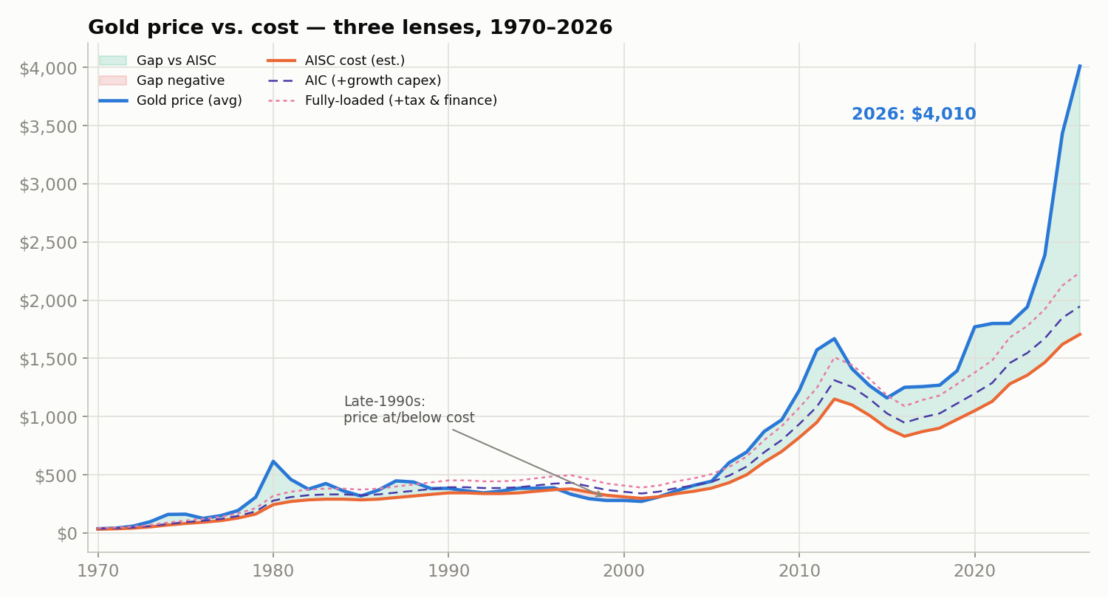
Figure 2 — Gold price vs. cost on three lenses, 1970–2026 (nominal US$/oz). Solid orange = AISC; dashed violet = AIC; dotted magenta = fully-loaded. Shaded band = gap vs AISC.
Three regimes stand out. In the late 1990s the average mine was under water: with gold near $270–300 and all-in costs around $320, many producers survived only by forward-selling future output — the era of “Brown’s Bottom,” when the UK sold roughly half its gold reserves at the lows. The 2011–2012 spike opened a wide margin that then collapsed, forcing a brutal cost-cutting cycle. Today the band is the widest it has ever been.
A caveat on the cost line: a standardised AISC metric only exists from 2013 (with WGC’s back-series to Q1 2010). The pre-2010 portion here is a cash-cost-based reconstruction scaled toward an all-in basis, so treat the long-run cost series as indicative of the margin’s shape rather than a precise dollar figure in any given early year.

Price gap by lens — choose your cost basis
“The gap” depends entirely on which cost you subtract. The stricter the lens, the smaller the margin — but even on the fullest, tax-and-finance-loaded basis, producers keep almost half of a $4,010 ounce. The three lenses:
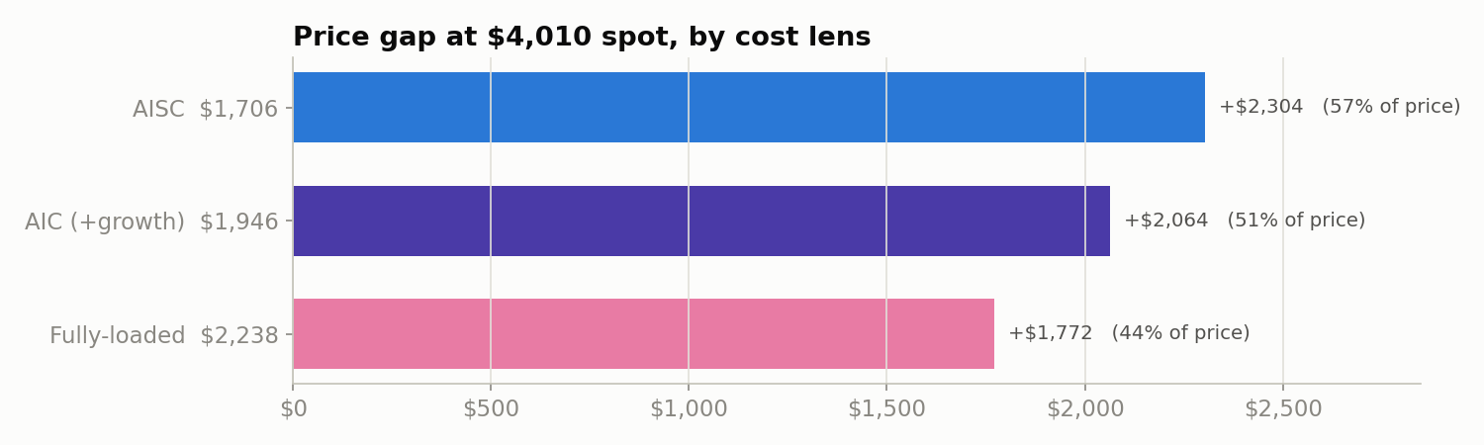
Figure 2b — The price gap at $4,010 spot under each cost lens.
Cost lens | Cost ($/oz) | Gap at spot | % of price
AISC | 1,706 | +2,304 | 57%
AIC (+ growth capex & exploration) | 1,946 | +2,064 | 51%
Fully-loaded (+ 15% tax & finance) | 2,238 | +1,772 | 44%

5. Who holds the gold — and why it drives price
Almost every ounce ever mined still exists — about 219,891 tonnes of above-ground stock at end-2025, roughly two-thirds of it mined since 1950. Because gold supply is a giant stock rather than a flow, who owns that stock and whether they are buying or selling matters more to price than the ~3,700 tonnes of new mine output each year (which adds under 2% to the total annually).
Above-ground stock, end-2025 | Tonnes | Share
Jewellery | 97,645 | 44%
Bars, coins & ETFs | 50,978 | 23%
Central banks (official reserves) | 38,666 | 18%
Other / industrial | 32,602 | 15%
Total | 219,891 | 100%

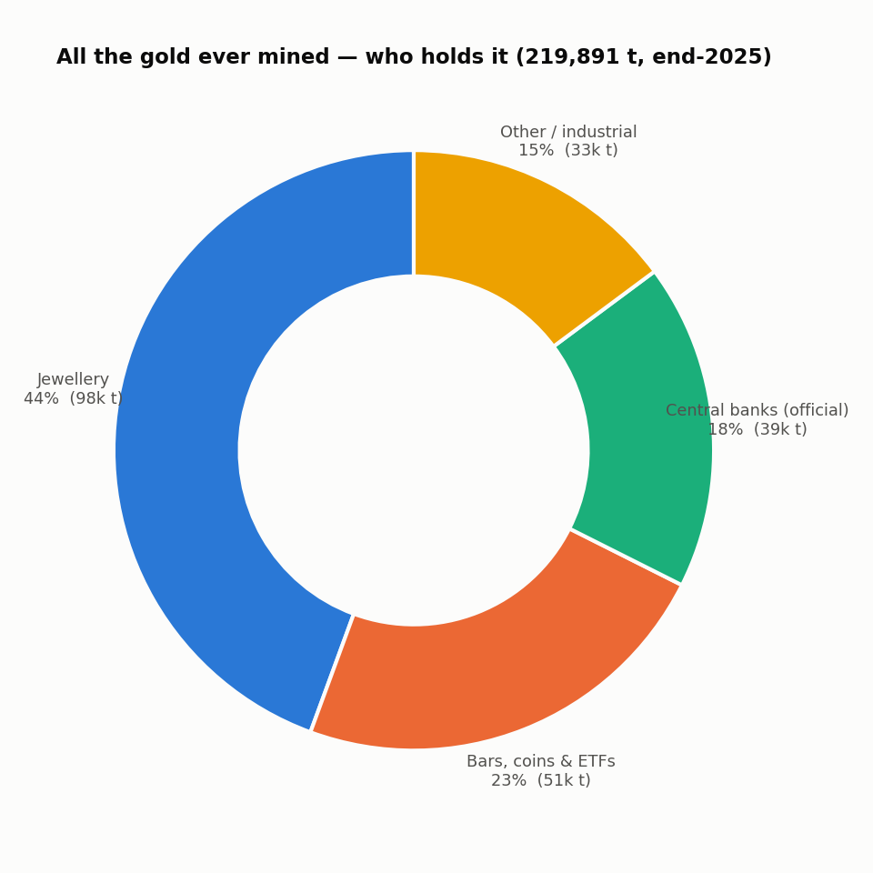
Figure 3 — The 219,891 tonnes of above-ground gold, split by holder category.

The sovereign layer, and the swing factor of the 2020s
The United States holds by far the most official gold — 8,133.5 tonnes, about 78% of its foreign reserves — followed by Germany (3,350t), the IMF (2,814t), Italy and France (each ~2,440t). But the story of the 2020s is at the margin: emerging-market central banks led by China, Russia, Turkey, India and Poland have been accumulating aggressively to diversify away from the dollar.
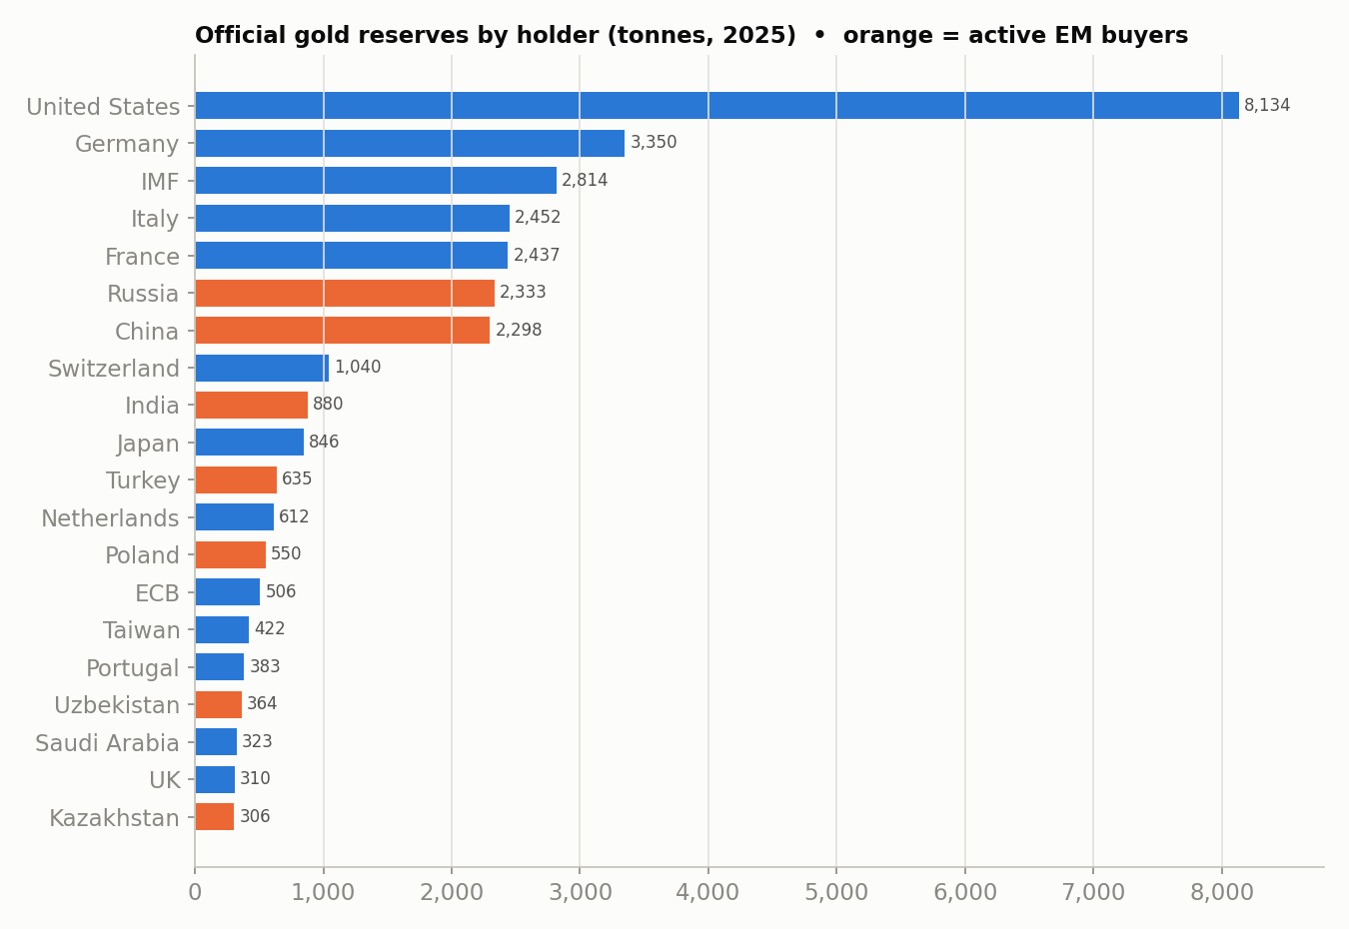
Figure 4 — Official gold reserves by holder (tonnes, 2025). Orange marks the active emerging-market accumulators.
The pivotal shift: after two decades as net sellers (the 1999 Central Bank Gold Agreement era), central banks turned net buyers in 2010 and then bought more than 1,000 tonnes in each of 2022, 2023 and 2024 — more than double the 2010–2021 average of 473 t/yr. Official reserves have climbed from a ~30,500-tonne low around 2008 back to a record 38,666 tonnes. That relentless official bid is the demand story sitting underneath gold’s move from $1,800 to $4,000.
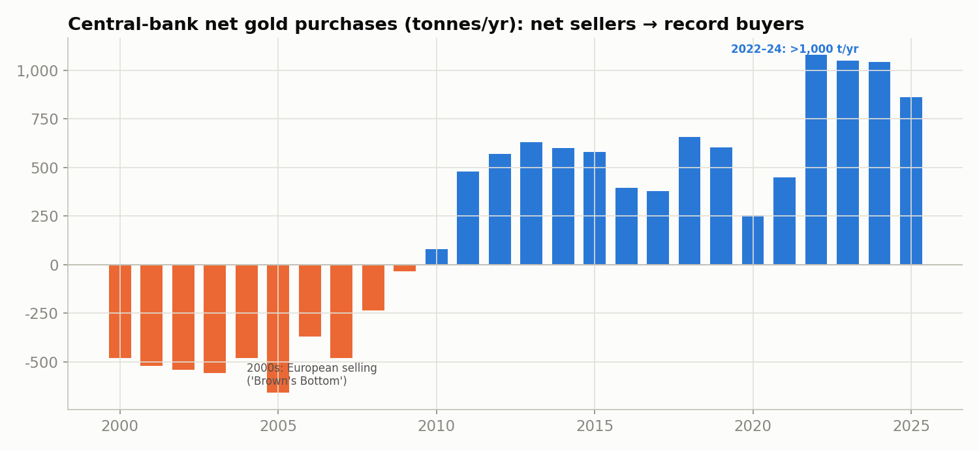
Figure 5 — Central-bank net gold purchases (tonnes/yr): from net sellers in the 2000s to record buyers in the 2020s.

6. Three investor reads — AI simulations
These are AI simulations, not the real people. The three “reads” below were written by Claude (an AI) from each investor’s publicly documented positions, to offer contrasting perspectives on the cost-versus-price picture. Stanley Druckenmiller, Paul Tudor Jones and Ray Dalio did not write, review, approve or contribute to any of this, and are in no way associated with this report or its author. The quotations are genuine and sourced; everything else is the author’s framing of their known views. All three lean bullish by design, so this is deliberately not a balanced market view — and it is not investment advice.

Stanley Druckenmiller — own it, currency debasement
Verdict: Gold is a bet against every government’s incentive to inflate away its debt. The ~$1,700 cost floor is almost irrelevant — the trade is the deficit.
- On cost: a rising cost curve underwrites the downside — disciplined miners won’t flood the market with new ounces even at record margins, so supply stays tight.
- His real driver: fiscal profligacy (a ~$37T US debt load) and a Fed that can’t stay tight; he has warned the dollar may not be the world’s reserve currency in 50 years and has held Barrick Gold.
- Risk he’d flag: he sizes to conviction and exits fast — a genuinely hawkish, deficit-cutting regime would break the thesis.
“I wanted to own some currency and no country wants its currency to strengthen… Gold was down a lot, so I bought it.” — Druckenmiller, on his gold rationale

Paul Tudor Jones — long, “all roads lead to inflation”
Verdict: The only politically possible way out of the debt is to inflate it away. Own gold and things that can’t be printed; be short bonds.
- On cost: costs and price both ratchet up with inflation — that is the mechanism, not a problem. Gold’s producing-cost floor rises with the very currency it is escaping.
- His real driver: deficits and negative real rates; he owns gold and bitcoin together as the inflation-hedge pair and calls 2025 markets “more explosive than 1999.”
- Risk he’d flag: a spike in real rates (bonds suddenly attractive) is gold’s classic enemy — he trades around it rather than marrying the position.
“All roads lead to inflation… I want to own gold, I want to own Bitcoin.” — Tudor Jones, CNBC 2024–2025

Ray Dalio — structural diversifier, not a trade
Verdict: Hold about 10–15% in gold. It is the one major reserve asset that is nobody’s liability — the hedge for the late stage of a long-term debt cycle.
- On cost: production economics are secondary; gold’s value is monetary. In a debt “doom loop,” the printing press — not the mine — sets the price.
- His real driver: sovereign over-indebtedness and de-dollarisation; central banks buying gold is the thesis visibly playing out.
- Risk he’d flag: gold pays no yield and can stagnate for years — it is portfolio ballast, not the engine.
“Gold is the only asset that isn’t someone else’s liability; hold something like 10–15% as diversification against debt risk.” — Dalio, on portfolio construction

Methodology & caveats
- Headline AISC/AIC & above-ground stock: World Gold Council (Q4 2025 AISC $1,706/oz; end-2025 stock 219,891 t) and Metals Focus. AIC is estimated as AISC plus typical growth capex and exploration.
- Fully-loaded cost & the tax/finance lens: the 15% charge added to AIC (≈$292/oz → ≈$2,238) is an analytical assumption, not a WGC-reported figure, standing in for corporate income tax plus interest/financing on deployed capital. Effective tax + financing loads vary by company, jurisdiction and leverage, so treat the fully-loaded lens as illustrative.
- Country-level AISC is estimated. A standardised AISC metric only dates to 2013 and few countries publish one, so per-country values here are modelled from WGC regional figures (Africa $1,532, N. America $1,508, Oceania $1,464, S. America $1,197 in Q3 2024), the Metals Focus cost curve, and recent company reports (Endeavour W. Africa $1,433; Harmony S. Africa $1,806; Agnico $1,517; Newmont $1,302; Barrick ~$1,581).
- The cost stack is a representative build-up scaled to the current AISC level, anchored on WGC's Q3 2024 components (then sustaining capex $303/oz, royalties $90/oz, both since risen); the plotted bars are illustrative, and individual mine economics vary widely.
- The pre-2010 cost line is a cash-cost-based reconstruction (AISC did not exist then). Treat the long-run cost series as indicative of the margin, not a precise annual cost.
- Production & reserves by country: USGS Mineral Commodity Summaries 2025 (world mine production ~3,300 t on the USGS measure; ~3,661 t on the WGC 2024 measure).
- Prices: LBMA/MetalCharts annual averages; spot (~$4,010) via Fortune/Forbes, 20 July 2026. Reserves by country & central-bank flows: World Gold Council / IMF IFS (September 2025).

This is an illustrative research briefing — not investment advice, and not a recommendation to buy, sell or hold gold or any other asset. The three investor “reads” in section 6 are AI simulations of documented public positions, not statements by, or endorsed by, the named individuals. Figures are best-available estimates as of 21 July 2026 and carry the uncertainties noted above.

Sources
- World Gold Council — AISC data & cost curve — https://www.gold.org/goldhub/data/aisc-gold
- World Gold Council — “Ever upwards for AISC” (regional variations) — https://www.gold.org/goldhub/gold-focus/2025/03/ever-upwards-aisc-distinct-regional-variations-are-emerging
- World Gold Council — How much gold has been mined — https://www.gold.org/goldhub/data/how-much-gold
- World Gold Council — Gold demand trends, full-year 2025 (supply) — https://www.gold.org/goldhub/research/gold-demand-trends/gold-demand-trends-full-year-2025/supply
- World Gold Council — Central-bank gold reserves & demand — https://www.gold.org/goldhub/data/gold-reserves-by-country
- USGS — Mineral Commodity Summaries 2025 (Gold) — https://pubs.usgs.gov/periodicals/mcs2025/mcs2025-gold.pdf
- Metals Focus / Selborne Research — AISC benchmarks 2026 — https://selborneresearch.com/guides/mining/aisc-benchmarks/
- S&P Global — Gold AISC in US, Canada up YoY — https://www.spglobal.com/market-intelligence/en/news-insights/research/2025/10/gold-all-in-sustaining-costs-in-us-canada-up-yoy-margins-to-widen-further
- MetalCharts — Gold price history 1970–2026 — https://metalcharts.org/gold-price-history
- Fortune — Current price of gold, 20 July 2026 — https://fortune.com/article/current-price-of-gold-07-20-202/

About. This project is by Hulki Okan Tabak — with Claude. His collected works — books, photographs, essays, games, artworks, and his other experiments — live at hulkiokantabak.github.io/hulkiokantabak.com.

